PROJECT REPORT


American International University-Bangladesh
Course name – Introduction to Data science

Faculty – kamrun Naher koli
SECTION -E
GROUP-I

GROUP MEMBER:
Name | Id
Md. Easin Khandokar | 22-46515-1
Provakar Sagor | 22-46639-1
Sadia Afroz Shuprova | 22-46462-1

Dataset

The dataset explores factors affecting an individual’s annual income, influenced by attributes like education, age, gender, and occupation. It contains 16 columns, with 14 features describing demographics and personal information, and a target variable income categorized as <=50K or >50K. This widely used KNN dataset serves as an excellent example for data preprocessing and machine learning practice. Analysis can reveal patterns, such as older and more educated individuals tending to earn higher incomes. It provides a foundation for building predictive models to estimate income levels based on personal attributes.

Dataset link: https://www.kaggle.com/datasets/wenruliu/adult-income-dataset

Import library
Code

library(dplyr)
library(ggplot2)
library(caret)
library(reshape2)
library(Amelia)

This code loads important R libraries to work with data and model it, dplyr, ggplot2, and reshape2 help to manipulate data and visualize it, and caret is employed to work with machine-learning processes. Amelia allows management and input of missing data.

Import Dataset
code
df <- read.csv ("C:/Users/asus/OneDrive/Desktop/adult_income/adult.csv", stringsAsFactors = FALSE)

print(head(df))
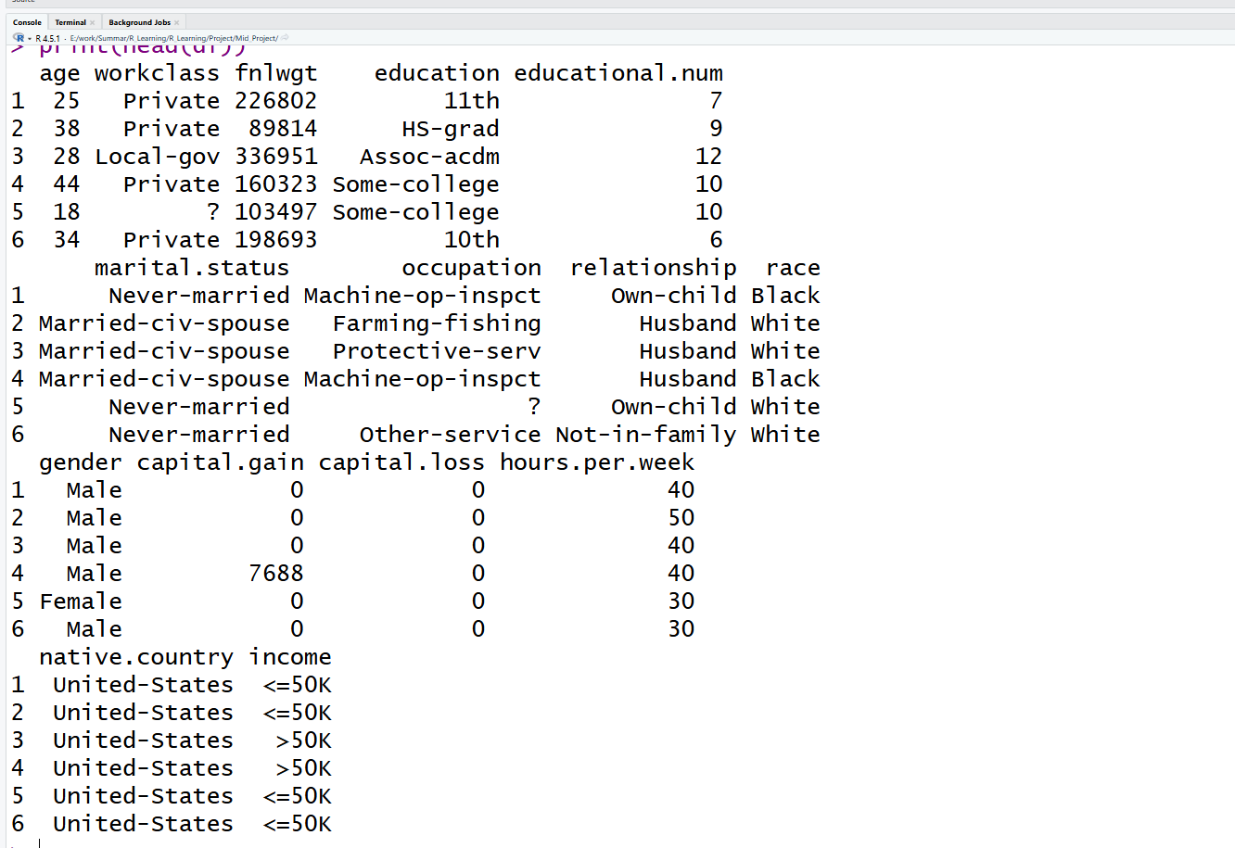

print(str(df))
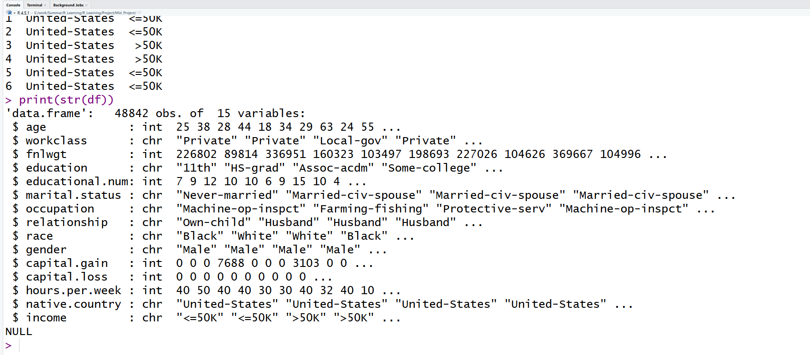
The dataset contains 48,842 observations and 15 variables, including demographic, work, and income-related attributes. Most variables are numeric or categorical, reflecting typical features used for income classification tasks.

print(summary(df))
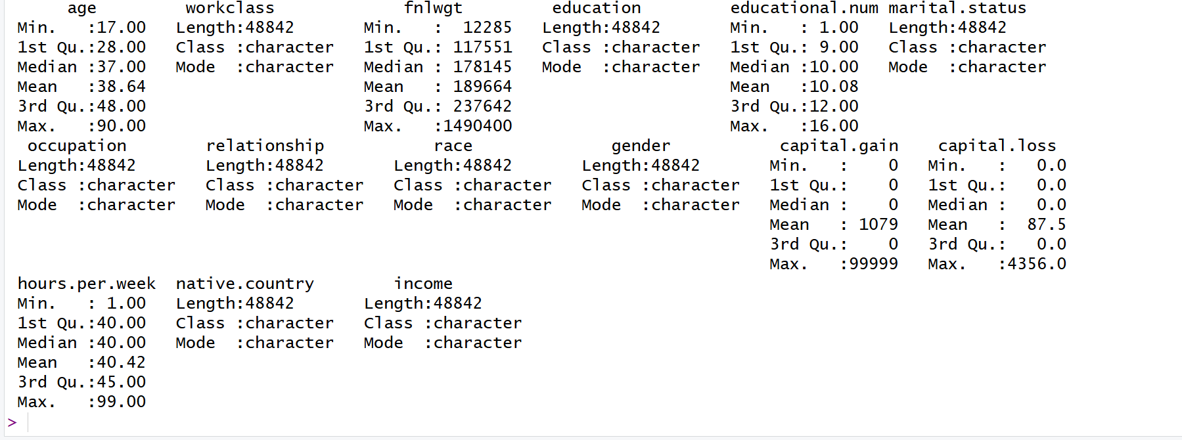

The summary shows reasonable distributions for age, education level, and work hours, while variables like capital.gain and capital.loss are highly skewed with many zeros. Most categorical fields contain diverse but well-structured values suitable for modeling.

Unique Value
code
print(unique(df$workclass))
print(unique(df$education))
print(unique(df$occupation))
print(unique(df$relationship))
print(unique(df$race))
print(unique(df$gender))
print(unique(df$income))
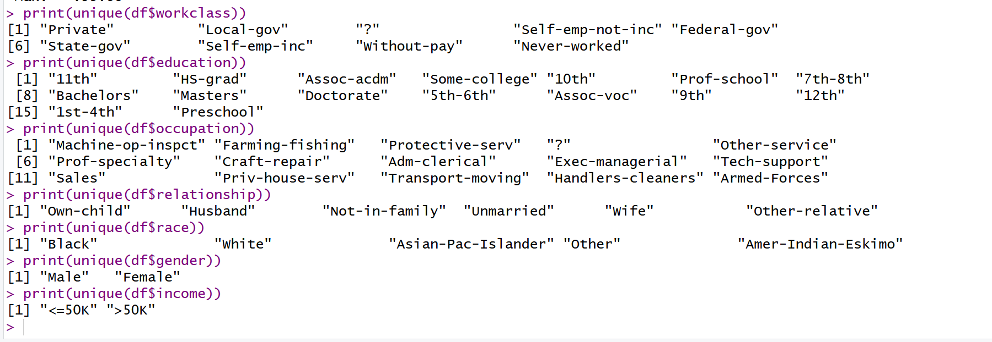
The categorical variables show a wide range of distinct values, including several unknown entries marked as “?”. Key fields like gender and income have simple categories, while attributes such as workclass, education, and occupation are more diverse, reflecting varied population backgrounds.

Drop Column
Code
df <- df %>% select(-fnlwgt)
print(head(df))
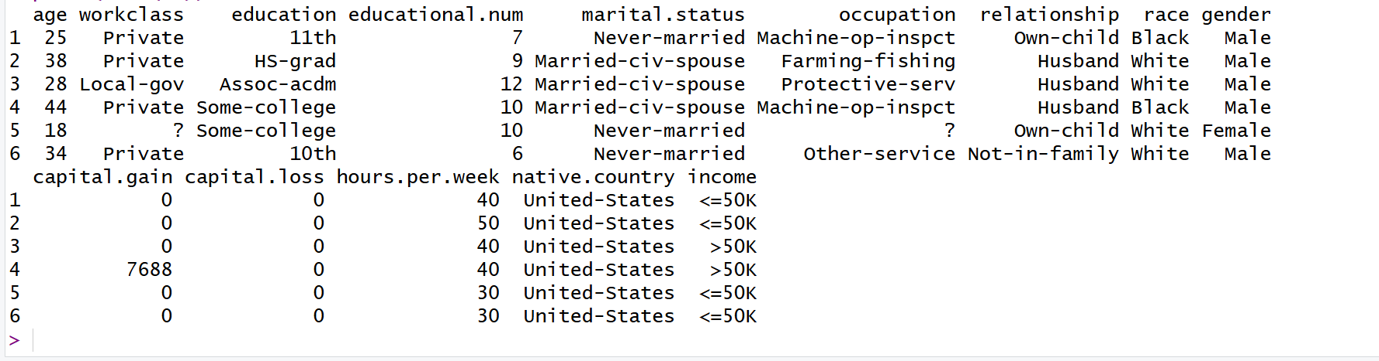
The unnecessary variable fnlwgt was removed to simplify the dataset and reduce noise. The updated dataset now contains only the relevant features for further analysis.

Missing value
code

df[df == "?"] <- NA
colSums(is.na(df))

head(df)
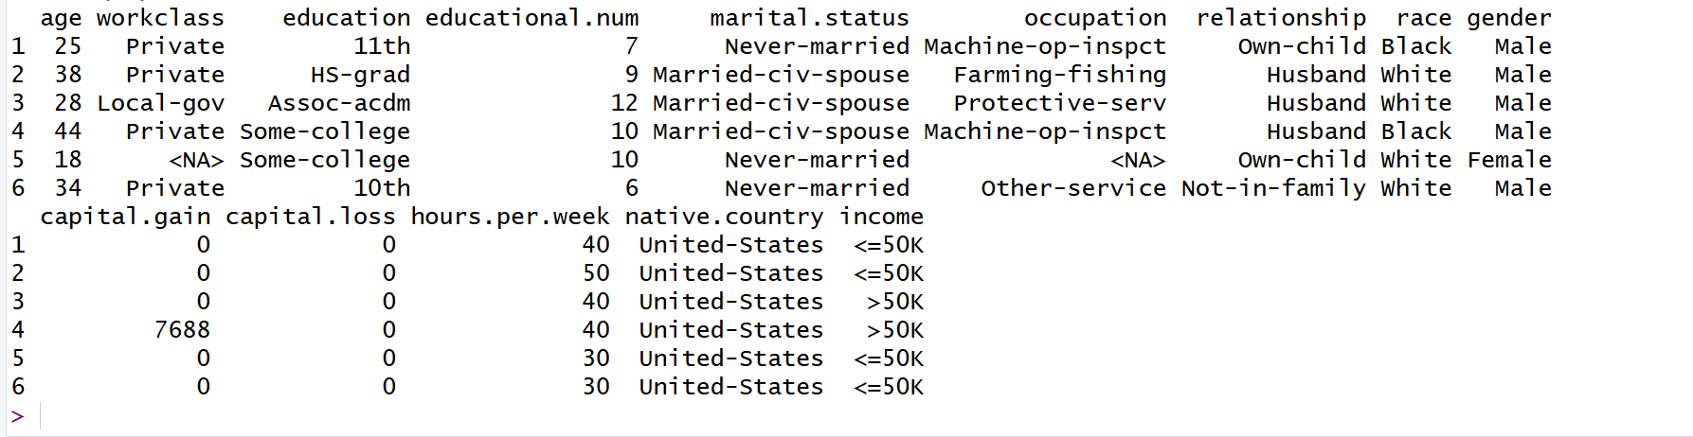
All placeholder “?” values were converted to proper NA entries to accurately represent missing data. A column-wise NA count was generated to identify variables requiring further cleaning or imputation.

df[!complete.cases(df), ]
missmap(df, main = "Missing Values Map", col = c("yellow", "steelblue"), legend = TRUE)
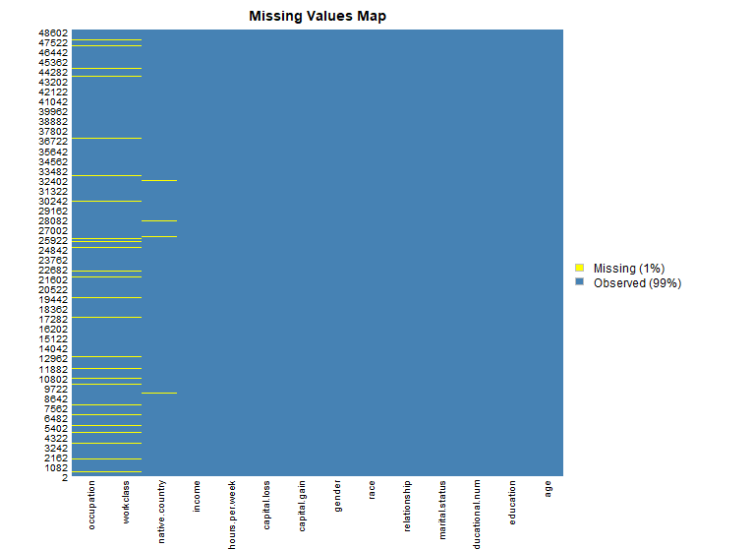

Rows with missing values were extracted to inspect incomplete records. A visual missing values map was plotted, clearly highlighting columns with gaps for targeted imputation.
Detect outliers in 'age' column

code
par(mar = c(5,4,4,2))

boxplot(df$age,
main = "Boxplot for Age",
col = "orange",
cex.main = 1.5,
cex.axis = 1.2)

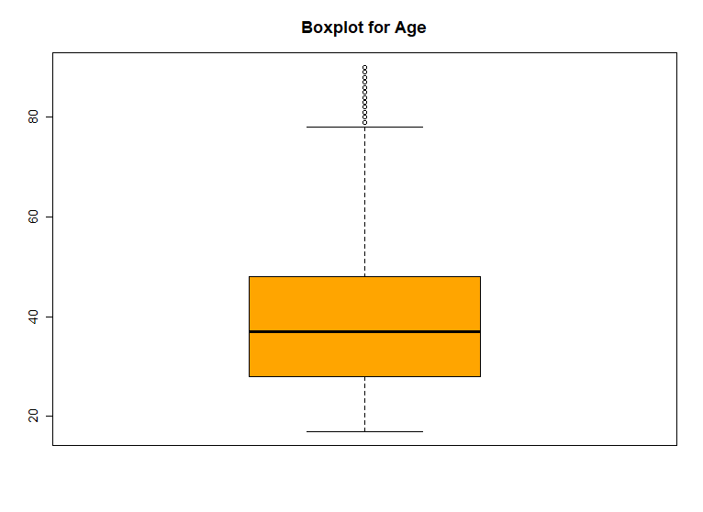
A boxplot of the age variable was created to visualize its distribution and detect outliers. The plot highlights the median, quartiles, and extreme age values in the dataset.

Convert numeric to categorical
Code
df$Age_group <- cut(df$age,
breaks = c(0, 25, 45, 65, 100),
labels = c("Young", "Adult", "Middle-aged", "Senior"))

df$Workload <- ifelse(df$hours.per.week > 40, "Full-time", "Part-time")
df
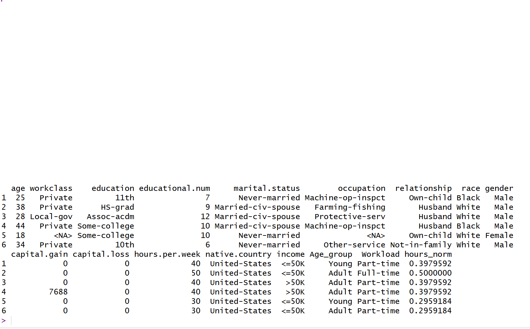

New categorical features were created: Age_group segments individuals by age ranges, and Workload classifies them based on weekly working hours. These transformations facilitate easier analysis and visualization of demographic and work patterns.

Normalize a continuous variable
Code
df$hours_norm <- (df$hours.per.week - min(df$hours.per.week, na.rm=TRUE)) /
(max(df$hours.per.week, na.rm=TRUE) - min(df$hours.per.week, na.rm=TRUE))
df

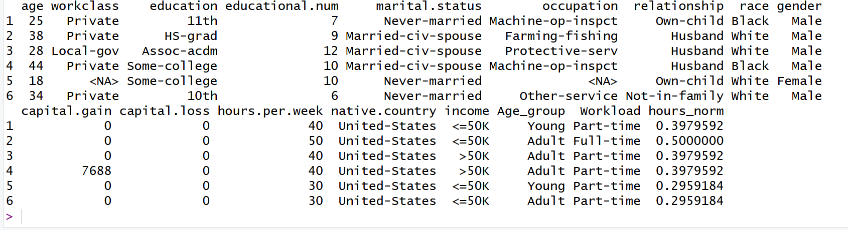
The hours.per.week variable was normalized to a 0–1 scale in the new hours_norm column. This standardization allows fair comparison and modeling alongside other features.

Remove duplicate rows
Code
df <- df %>% distinct()
sum(duplicated(df))
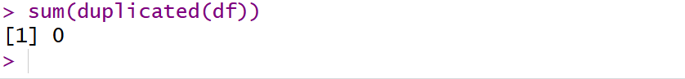
Duplicate records were removed from the dataset, ensuring each observation is unique. A check confirmed that no duplicates remain, maintaining data integrity for analysis.

Filtering the data
Code
df_filtered <- df %>% filter(age > 40)
df_filtered

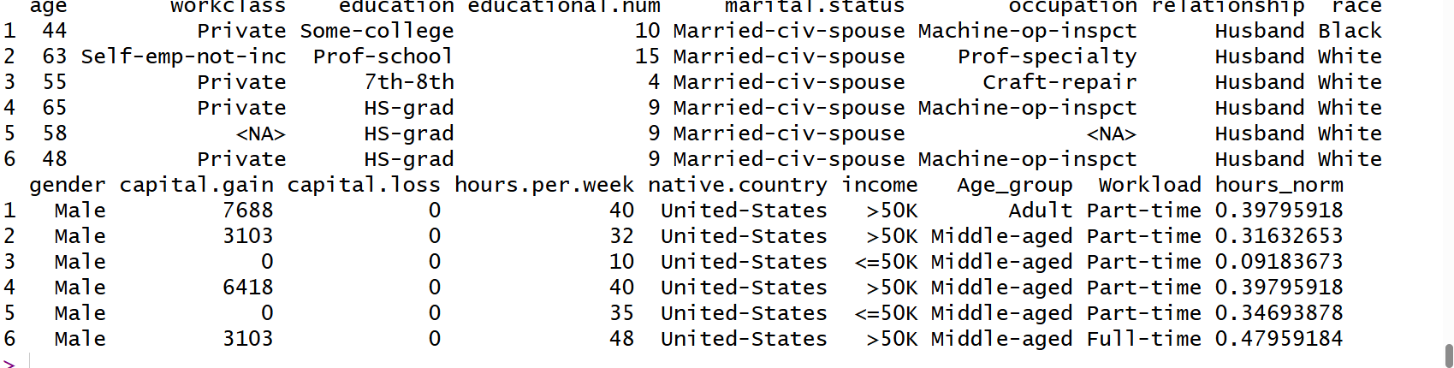
A subset of the dataset was created containing only individuals older than 40. This filtered data enables focused analysis on the middle-aged and senior population segments.

Handle Imbalanced Dataset
Code
table(df$income)

barplot(table(df$income),
col = c("skyblue", "orange"),
main = "Income Distribution",
xlab = "Income Category",
ylab = "Count")

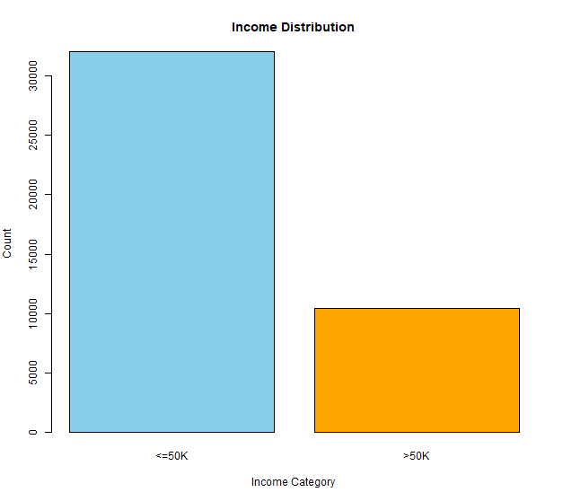

The income distribution was summarized and visualized using a bar plot. It clearly shows the count of individuals earning <=50K versus >50K, highlighting class imbalance in the dataset.

Train-Test Split
Code
set.seed(123)
trainIndex <- createDataPartition(df$income, p=0.7, list=FALSE)

train <- df[trainIndex, ]
test <- df[-trainIndex, ]

dim(train)
dim(test)

sizes <- c(nrow(train), nrow(test))
names(sizes) <- c("Train", "Test")

barplot(sizes,
col = c("steelblue", "orange"),
main = "Train vs Test Dataset Size",
ylab = "Number of Rows",
xlab = "Dataset")

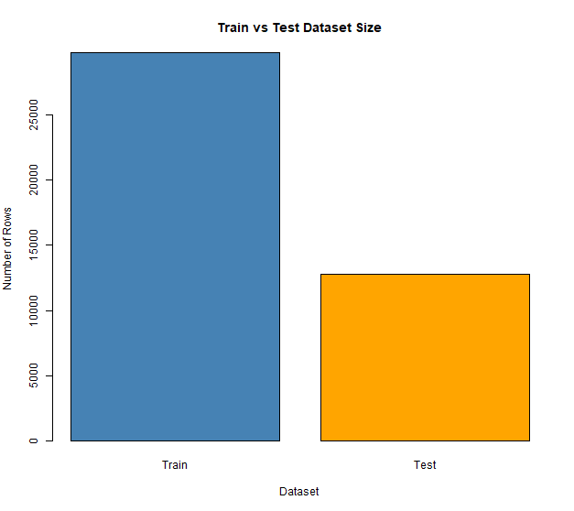

The dataset was split into 70% training and 30% testing sets to prepare for model building and evaluation. A bar plot visualizes the number of rows in each subset, confirming the partition sizes.

Descriptive Statistics
Code

age_summary <- df %>%
group_by(income) %>%
summarise(
mean_age = mean(age, na.rm = TRUE),
sd_age = sd(age, na.rm = TRUE),
median_age = median(age, na.rm = TRUE)
)
age_summary

age_long <- melt(age_summary,
id.vars = "income",
variable.name = "Statistic",
value.name = "Value")

ggplot(age_long, aes(x = income, y = Value, fill = Statistic)) +
geom_bar(stat = "identity", position = "dodge") +
labs(title = "Age Summary by Income Group",
x = "Income Category",
y = "Value") +
theme_minimal()

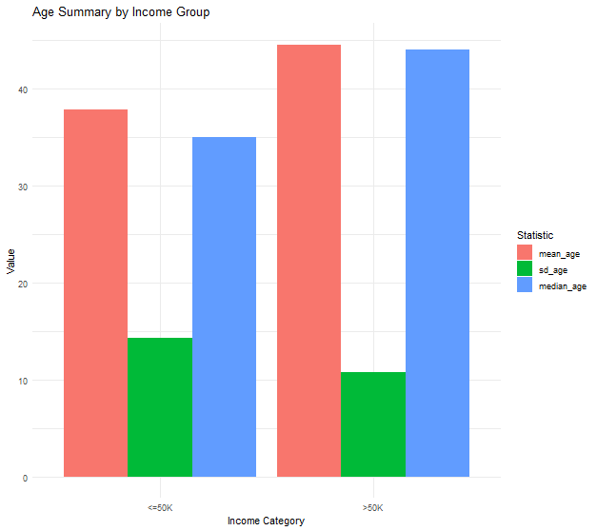

The age distribution was summarized by income category, calculating mean, standard deviation, and median ages. Individuals earning >50K are generally older (mean 44.3) than those earning <=50K (mean 36.9), with slightly less age variability. A bar plot was created to visually compare these statistics across income groups. This highlights that higher income is associated with older age in the dataset.

visualize education to hours.per.week

ggplot(df, aes(x = education, y = hours.per.week)) +
geom_boxplot() +
theme(axis.text.x = element_text(angle=90))

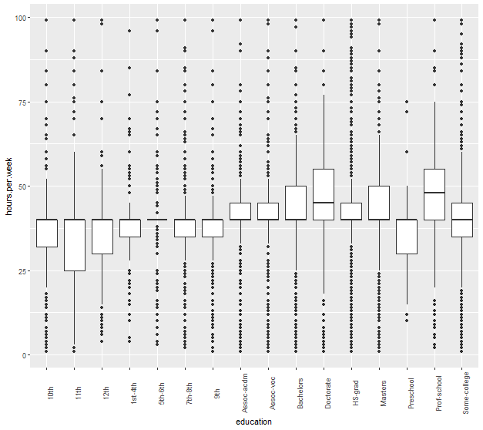
A boxplot was created to examine weekly working hours across education levels. It shows variations and potential outliers in hours, highlighting how education may influence workload patterns.

